Welcome to AA. Please Keep Coming Back!  Please see our district website for  updated meeting information. aaci11.org  Or:  Download the “Meeting Guide” app  On Google Play or The App Store  The Only Requirement For Membership  Is A Desire To Stop Drinking. | Welcome to AA. Please Keep Coming Back!  Please see our district website for  updated meeting information. aaci11.org  Or:  Download the “Meeting Guide” app  On Google Play or The App Store  The Only Requirement For Membership  Is A Desire To Stop Drinking.  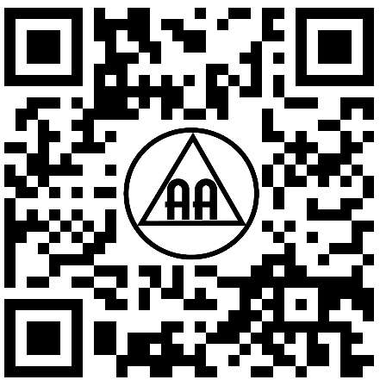
Welcome to AA. Please Keep Coming Back!  Please see our district website for  updated meeting information. aaci11.org  Or:  Download the “Meeting Guide” app  On Google Play or The App Store  The Only Requirement For Membership  Is A Desire To Stop Drinking. | Welcome to AA. Please Keep Coming Back!  Please see our district website for  updated meeting information. aaci11.org  Or:  Download the “Meeting Guide” app  On Google Play or The App Store  The Only Requirement For Membership  Is A Desire To Stop Drinking.
Welcome to AA. Please Keep Coming Back!  Please see our district website for  updated meeting information. aaci11.org  Or:  Download the “Meeting Guide” app  On Google Play or The App Store  The Only Requirement For Membership  Is A Desire To Stop Drinking. | Welcome to AA. Please Keep Coming Back!  Please see our district website for  updated meeting information. aaci11.org  Or:  Download the “Meeting Guide” app  On Google Play or The App Store  The Only Requirement For Membership  Is A Desire To Stop Drinking.
Welcome to AA. Please Keep Coming Back!  Please see our district website for  updated meeting information. aaci11.org  Or:  Download the “Meeting Guide” app  On Google Play or The App Store  The Only Requirement For Membership  Is A Desire To Stop Drinking. | Welcome to AA. Please Keep Coming Back!  Please see our district website for  updated meeting information. aaci11.org  Or:  Download the “Meeting Guide” app  On Google Play or The App Store  The Only Requirement For Membership  Is A Desire To Stop Drinking.
Welcome to AA. Please Keep Coming Back!  Please see our district website for  updated meeting information. aaci11.org  Or:  Download the “Meeting Guide” app  On Google Play or The App Store  The Only Requirement For Membership  Is A Desire To Stop Drinking. | Welcome to AA. Please Keep Coming Back!  Please see our district website for  updated meeting information. aaci11.org  Or:  Download the “Meeting Guide” app  On Google Play or The App Store  The Only Requirement For Membership  Is A Desire To Stop Drinking.
Pick Up The Phone Before You Pick Up A Drink. | Pick Up The Phone Before You Pick Up A Drink.
Pick Up The Phone Before You Pick Up A Drink. | Pick Up The Phone Before You Pick Up A Drink.
Pick Up The Phone Before You Pick Up A Drink. | Pick Up The Phone Before You Pick Up A Drink.
Pick Up The Phone Before You Pick Up A Drink. | Pick Up The Phone Before You Pick Up A Drink.
Pick Up The Phone Before You Pick Up A Drink. | Pick Up The Phone Before You Pick Up A Drink.

